**LAGOS STATE UNIVERSITY MUSLIM ALUMNI (LASUMA)**

**SHURAH COMMITTEE REPORT**

**PRESENTED AT THE**

**TRANSITIONAL CONFERENCE**

**HELD ON SATURDAY MUHARAM 7TH 1446 A. H**

**(13TH JULY 2024 C. E)**

**AT THE**

**LAGOS STATE UNIVERSITY CENTRAL MOSQUE**

**OJO, LAGOS.**

**LASUMA SHURAH COMMITTEE REPORT**

In the name of Allah, The Most Gracious, The Most Merciful.

Report of the Shurah Committee presented onSaturday Muharram 7th, 1446H (July 13th, 2024).

**Introduction**

Following the constitution of the Shurah committee and the official announcement by the LASUMA president in September 2023, the committee commenced the exercise. The Shurah committee was given the task of conducting, screening and selecting new set of executive members for the alumni with Alhaji Monsur Popoola as the Chairman and Alhaji Imam Abdul Hakeem Oshodi as the Secretary, while sister Mujidah Banks-Okelola, Doctor Abdul Fatah Abdul Yeqeen, Alhaji AbdulRazaq Sulaiman, Mallam Aina AbdulKabir, and Comrade Onibudo Abdul-Lateef were members of the committee.

A Google Docs form was designed to enable members nominate and be nominated irrespective of his or her location. Subsequently, the committee considered logistics, accessibility, global reach amongst other factors in designing a WhatsApp platform for correspondence and the screening of nominees.

There was a great concern for LASUMA to:

* Be repositioned.
* Renew and sustain the relationship with the LASU Muslim Community, Lagos Area unit and Area councils in Lagos state.
* Be more visible and impactful on the social media.
* Review LASUMA programs both physical and electronic medium.

**Nomination Form**

Following the constitution of the Shurah Committee to screen and select new set of executive members for LASUMA, the Shurah committee used the existing **LASUMA WhatsApp platform** to inform all members about the availability of Google nomination form. Furthermore, members were requested to kindly fill the form to nominate any member of their choice for the following positions:

1. President

2. Vice president

3. General Secretary

4. Assistant General Secretary

5. Public Relations Manager (PRM)

6. Financial Secretary

7. Treasurer

8. Welfare - Male

9. Welfare - Female

10. Ex-officios

The submission of Google nomination forms was designed to last for a week between September 26th to 30th with real time update on the trend of nominations by members for various executive positions. It was later extended till October due to the unpromising response from members. However, a total of 18 responses were received during the nomination exercise. (**See Fig.1 below**):

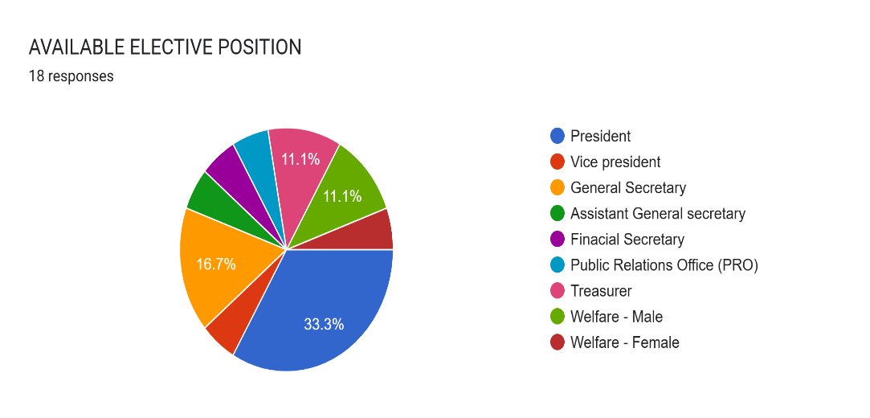

***Fig. 1: Percentage distribution of elective positions.***

Furthermore, over 65% of the nominees consented to their nominations (**see Fig.2 below**):

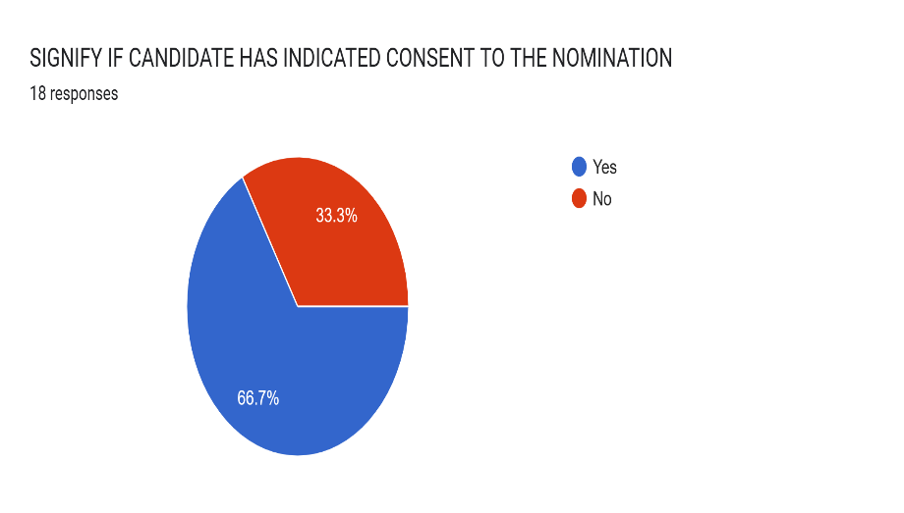

***Fig. 2: Percentage distribution of nominee’s consent.***

It must be added that some nominees were nominated for an executive post twice. Subsequently, for the screening exercise, the nominees were carefully added to the **WhatsApp platform** at different intervals which lasted for about two months due to the inability to reach all the nominees and the availability of Shurah Committee members for the screening exercise. After the screening exercise, the following nominees were later shortlisted and ratified by the Shurah Committee to serve as LASUMA executive members for the period 2024 to 2027 in Shaa Allah:

1. President - Dr. Anjorin Abdul Azeez

2. Vice President (I) Brother Abdul Lateef Onibudo

3. Vice president (II) - Dr. Dhikroh Sulaiman

4. General secretary –Mallam Alabidun Mahfouz

5. Assistant General Secretary –Brother AbdulGafar Adebowale

6. Welfare male –Brother Abdul Raheem Jenmi

7. Welfare female –HajiaMujidat Banks Okelola

8. Treasurer –Brother Tajudeen Osolo

9. Fin Sec –Brother Usman Hamed.

10. PRM - Brother Usman Abdul Gaffar

11. Ex-officios – Dr. Abdul Fatah Abdul Yaqeen, Alhaji Hon. Sulaimon Abdul Razak, Alhaji Hon. ImamAbdul Hakeem Oshodi and Alhaji Monsur Adebayo Popoola.

We glorify Allah for His endless guidance and also thank the Exco for entrusting the Shurah Committee with the responsibility of choosing the next set of executives for LASUMA. It must be added that for the alumni association to regain her lost glory, all hands must be on deck to make it more vibrant, visible and impactful. Hence, the following should be reviewed by the incoming set of executives in other to take the LASUMA to the next desirable and reputable level:

**Recommendations:**

* Collaboration with LASU MSSN at all levels.
* Renew and sustain the relationship with the Muslim Communities and the Area Council.
* Have a robust program that identifies and engages future members from matriculation.
* Coordination of undergraduates and graduates for better representation in the Alumni.
* Continuous improvement on the association’s activities that will enable global vibrancy.
* All avenues to launder LASUMAs image on the social medial should be identified and optimized as soon as possible.
* Regular e-meetings should be organized to enable and encourage membership participation.
* Pre-Ramadan, Ramadan lectures, Scholarship and other LASUMA programme should be redesigned with the view to laundering her image.

While wishing the incoming exco Allah’s guidance and protection, I say a BIG JazaakumuLlahu Khoiron to the members of the Shurah Committee for their selflessness, commitment and can-do attitude throughout the exercise. The team spirit is amazing and impressive!Let us keep it up! May Almighty Allah accept our efforts as act of worship and forgive our shortcomings (Aamiin).

**Monsur Adebayo Popoola**

*Chairman, Shurah Committee*

Vice President (Female)